**0.55T Prostate Diffusion-Weighted Imaging Using Multi-Shot EPI and Self-Supervised Learning Reconstruction**

Zhengguo Tan, Jacob Richardson, Thomas L Chenevert, Hero Hussain, Michael Jaroszewicz, Yun Jiang, Nicole Seiberlich, Vikas Gulani

**IMPACT** (40 words)

This study supplies a reliable and accurate prostate DWI method at 0.55T, leveraging multi-shot EPI acquisition and self-supervised unrolled joint reconstruction. This method will allow for large cohort prostate patient studies at 0.55T.

**SYNOPSIS** (100 words)

**Motivation**: Clinical prostate diffusion-weighted imaging based on EPI at 0.55T suffers from poor resolution and low signal-to-noise ratio.

**Goals**: The goal is to develop an acquisition and reconstruction strategy that enables high-resolution prostate DWI at 0.55T.

**Approach**: This study leverages accelerated multi-shot EPI and ADMM unrolled reconstruction with self-supervised learning.

**Results**: Our results demonstrate accurate ADC values with 1.6 mm in-plane resolution at 0.55T.

**INTRODUCTION**

*(Why was this study/research performed? What unsolved problem are you addressing?)*

Prostate cancer is the most common cancer in men and one of the leading causes of cancer deaths [1]. Diffusion-weighted imaging (DWI) and its derived apparent diffusion coefficient (ADC) are two key image contrasts for clinical diagnosis and assessment of prostate cancer, according to PI-RADS [2]. Recently, there has been increasing interest in adopting DWI at 0.55T due to reduced field inhomogeneity in the setting of hip implants and rectal gas [3]. However, EPI at 0.55T still suffers from poor resolution and low SNR. To address these challenges, this study aims to develop an acquisition and reconstruction strategy leveraging accelerated multi-shot EPI and self-supervised reconstruction unrolling ADMM (alternating direction method of multipliers).

**METHODS**

*(How did you study this problem?)*

**Multi-Shot EPI with Repetition-Shifted Encoding**

Figure 1 lists acquisition parameters of a clinical single-shot EPI sequence and a proposed multi-shot sequence. The proposed 2-shot interleaved EPI with 4-fold in-plane acceleration per shot reaches 1.6 mm in-plane resolution. In addition, the acquired phase-encoding lines in one repetition are shifted by one line with respect to its preceding repetition, achieving complementary k-q-space sampling [4]. The 3-scan trace diffusion acquisition mode is employed in both protocols. In this mode, trace-weighted images can be computed as geometric means of three-orthogonal diffusion-weighted images with the same b-value. Subsequently, the ADC map can be fitted from the following equation:

$TRACE_{i}=ρ⋅exp⁡(-b_{i}⋅ADC)$ (1)

Here, i denotes the index of different b-values acquired. While Protocol #1 uses only three b-values with many averages, we propose using six different b-values but fewer averages for more contrasts.

Scans at 0.55T (FreeMax, Siemens, Erlangen, Germany) were conducted on the caliber diffusion phantom and healthy male subjects with written consent in compliance with IRB.

Tabel 1. 0.55T prostate DWI acquisition protocols



**ADMM Unrolled Self-Supervised Reconstruction**

We extend the ADMM unrolled self-supervised reconstruction [5] for prostate DWI at 0.55T. The ADMM unrolled reconstruction formulates a joint k-q-space minimization problem:

$$argmin{\left|\left|y-Ax\right|\right|}_{2}+λR(x)$$

where x consists of all diffusion-weighted images, the chained operator A maps x to the acquired k-space data y through the multiplication of shot-to-shot phase variation, coil sensitivities, Fourier transform, and undersampling patterns. The regularization term R(x) is represented by the 2D ResNet [6], which is trained via the data splitting mechanism [7,8]. Here, we split the k-space data spatially. The model is trained and tested on a A40 GPU with 48 GB memory (NVIDIA, Santa Clara, CA). After reconstruction, ADC maps are computed with MRtrix3.

**RESULTS**

*(Report the data, analyses and/or outcomes)*

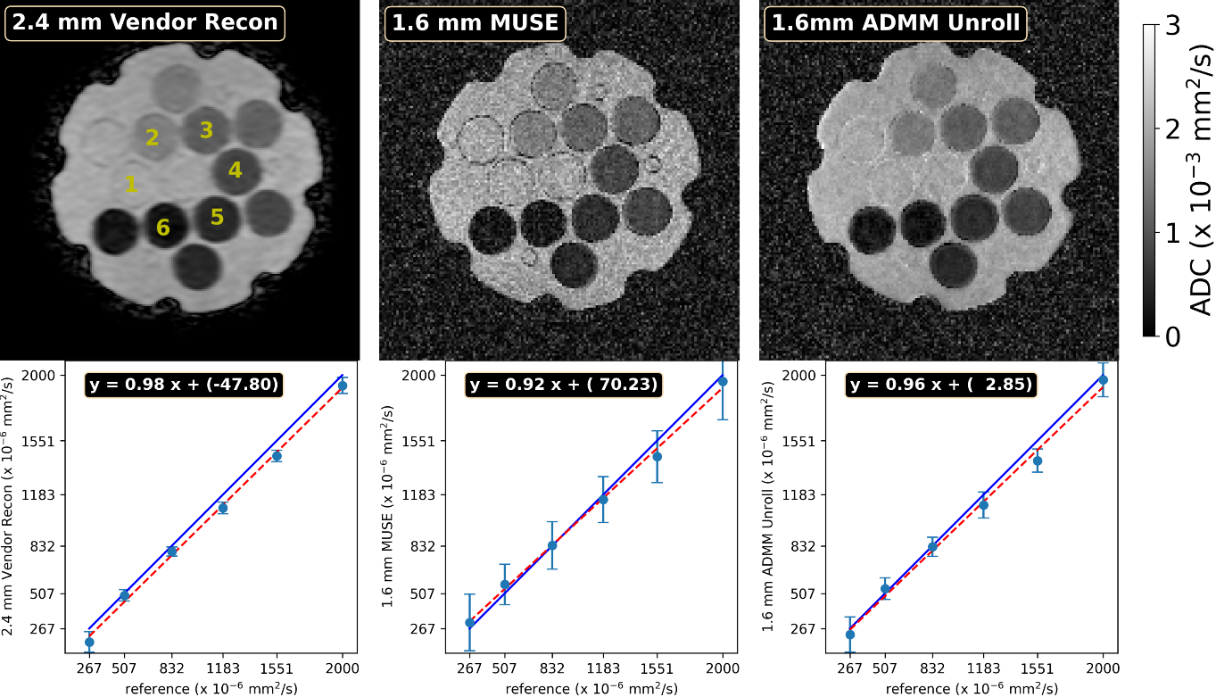

Figure 1. ADC validation using the caliber diffusion phantom. (Top) reconstructed ADC maps from both protocols. (Bottom) region-of-interest analysis of ADC values.

Figure 1 validates the quantitative ADC values using the caliber diffusion phantom. Both protocols supply accurate ADC values. The proposed ADMM unrolling significantly removes noise compared to the parallel imaging as MUSE reconstruction [9]. Larger standard deviation is seen in tube 6, because of the low ADC value (i.e., low diffusion contrast-to-noise ratio).

Figure 2. Comparison of trace-weighted images at the b-value of 500 s/mm2: (top) Protocol #1 with 2.4 mm vendor reconstruction, (middle and bottom) the proposed 1.6 mm protocol with MUSE and ADMM unrolled reconstruction, respectively.

Figure 2 compares the trace-weighted images at the b-value of 500 s/mm2. The proposed ADMM unrolling shows significantly reduced noise compared to MUSE and improved spatial resolution compared to the vendor reconstruction.

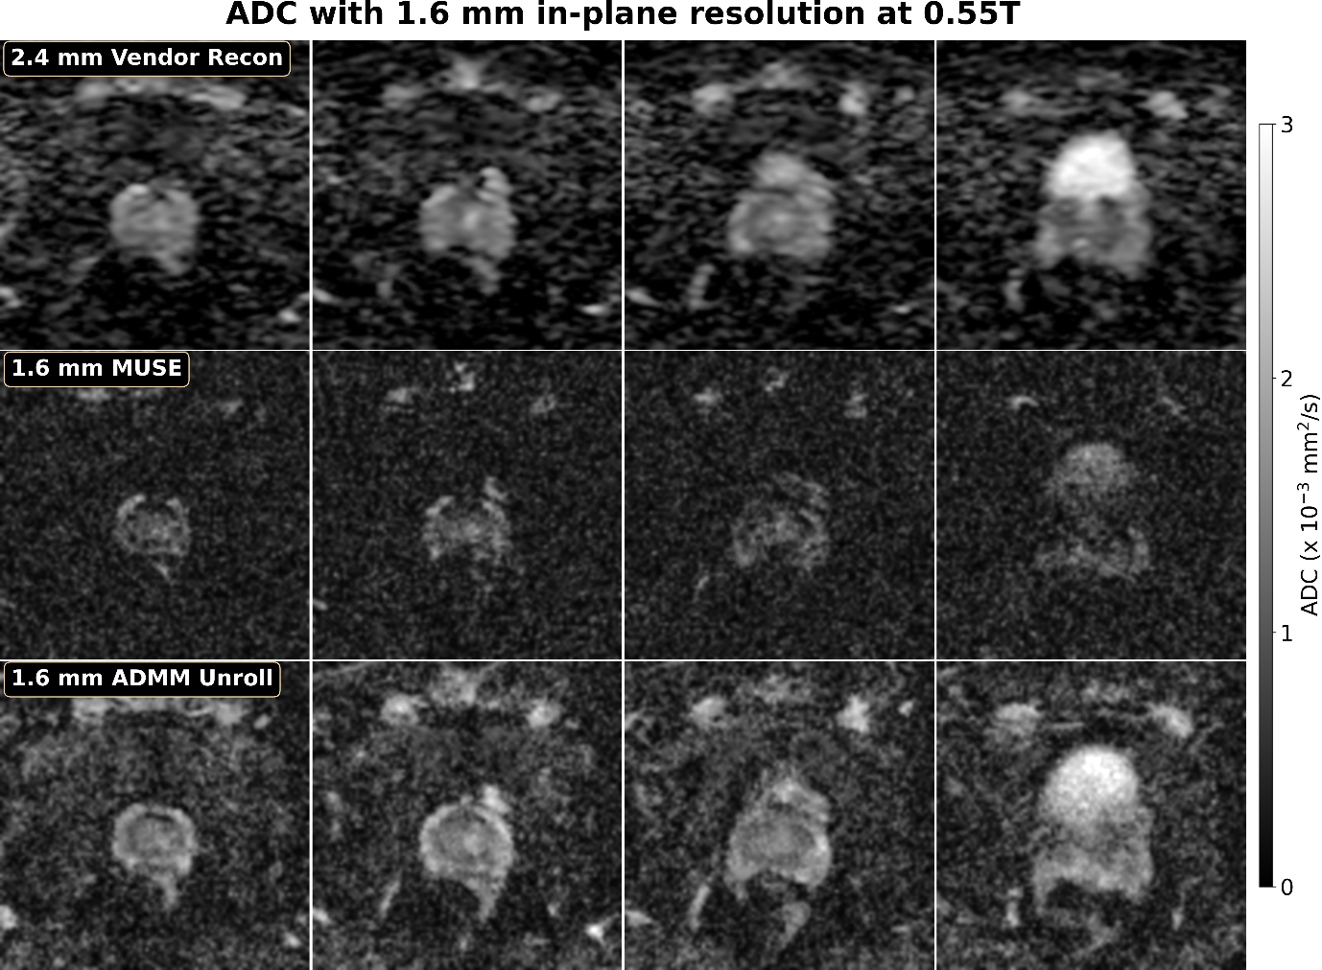

Figure 3. ADC maps from (top) 2.4 mm in-plane resolution and vendor online reconstruction (Protocol #1), (middle and bottom) 1.6 mm in-plane resolution (Protocol #2) with MUSE and ADMM unrolled reconstruction.

Figure 3 shows the quantitative ADC maps from both acquisition protocols. While MUSE suffers from severe noise, ADMM unrolling significantly reduces noise and preserves sharp delineation of prostate peripheral zone. A region of interest analysis of the central gland shows similar ADC values (1.3 x 10-3 mm2/s) from both protocols. However, the ADC value of the peripheral zone from ADMM unrolling is 1.9 x 10-3 mm2/s, higher than Protocol #1 that yields 1.5 x 10-3 mm2/s.

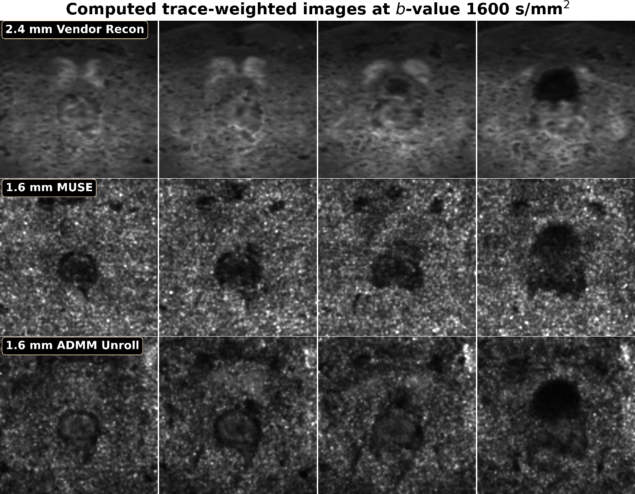

Figure 4. Computed trace-weighted images at the b-value of 1600 s/mm2.

Figure 4 displays computed trace-weighted images at the b-value of 1600 s/mm2. The vendor reconstruction illustrates blurred boundaries between prostate zones. The proposed ADMM unrolling delivers clear definition of all zones. The central gland shows slightly brighter trace signal than the peripheral zone because of its higher ADC value.

**DISCUSSION**

*(How do you interpret the results?)*

This study presents a high in-plane resolution DWI technique at 0.55T based on multi-shot EPI acquisition and ADMM unrolled reconstruction. Clinical prostate DWI based on single-shot EPI renders limited spatial resolution. Spatial interpolation and filtering from the vendor reconstruction shows strong blurring in the computed high b-value trace-weighted images and may be the cause of the reduced ADC value in the peripheral zone. In contrast, our proposed method acquires true 1.6 mm in-plane resolution, and ADMM unrolling effectively reduces noise while preserving sharp delineation of prostate regions.

**CONCLUSION**

*(What is the relevance to clinical practice or future research?)*

This study develops a high-resolution prostate DWI technique at 0.55T. This technique addresses the challenge of reduced SNR at 0.55T and may serve as a useful tool for prostate imaging in patients for whom 3T imaging is sub-optimal.

**REFERENCES**

[1] Siegel RL, Giaquinto AN, Jemal A. Cancer statistics, 2024. CA: A Cancer Journal for Clinicians 2024;74:12-49. doi:10.3322/caac.21820

[2] Weinreb JC, Barentsz JO, Choyke PL, Cornud F, Haider MA, Macura KJ, et al. PI-RADS Prostate Imaging – Reporting and Data System: 2015, Version 2. European Urology 2016;69:16-40. doi:10.1016/j.eururo.2015.08.052

[3] Kelsey LJ, Seiberlich N, Morehouse J, et al. Routine and advanced neurologic imaging at 0.55T MRI: opportunities and challenges. RadioGraphics 2025;45:e240076. doi:10.1148/rg.240076

[4] Tan Z, Liebig PA, Heidemann RM, Laun FB, Knoll F. Accelerated diffusion-weighted MRI at 7T: joint reconstruction for shift-encoded navigator-based interleaved EPI (JETS-NAViEPI). Imaging Neuroscience 2024;2:imag-2-00085. doi:10.1162/imag_a_00085

[5] Tan Z, Liebig PA, Hofmann A, Laun FB, Knoll F. High-resolution diffusion-weighted imaging with self-gated self-supervised unrolled reconstruction. Magn Reson Med (2025).

[6] He K, Zhang X, Ren S, Sun J. Deep residual learning for image recognition. CVPR (2016). doi:10.1109/CVPR.2016.90

[7] Yaman B, Hosseini SAH, Moeller S, Ellermann J, Ugurbil K, Akcakaya M. Self-supervised learning of physics-guided reconstruction neural networks without fully sampled reference data. Magn Reson Med 2020;84:3172-3191. doi:10.1002/mrm.28378

[8] Yaman B, Hossein SAH, Akcakaya M. Zero-shot self-supervised learning for MRI reconstruction. ICLR (2022).

[9] Chen NK, Guidon A, Chang HC, Song AW. A robust multi-shot scan strategy for high-resolution diffusion weighted MRI enabled by multiplexed sensitivity-encoding (MUSE). NeuroImage 2013;72:41-47. doi:10.1016/j.neuroimage.2013.01.038